**Elections Information 2024**

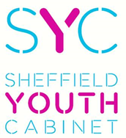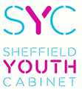

**Are you aged 11 to 17?**

**Do you have a voice and opinions to match?**

**Do you have something to say as a young person?**

**Could you represent others and get things done?**

**Then make a difference and stand for election as a Youth Councillor in the 2024 Youth Cabinet Elections!**

**You will also be expected to:**

**What is Sheffield Youth Cabinet?**

* Attend monthly Full Cabinet Meetings as well as action groups in between to work on identified issues.
* Meet with councillors, MP’s, Ministers, and key decision makers.
* Attend a residential
* Attend regional meetings.
* Attend national events where role permits.
* Be part of exciting projects and activities chosen by you and the young people you represent locally and city-wide.

Sheffield Youth Cabinet is made up of 45 seats of which 35 are elected young people from across the city of different ages, backgrounds and abilities.

The cabinet ensures that the voices of young people are heard and taken into account by decision makers locally, regionally and nationally.

**What will I have to do?**

You are elected into the Youth Cabinet for 2 years. During this time, you will:

* Attend regular meetings to work on identified issues.
* Consult and work closely with young people in your area.
* Participate in local and national projects and campaigns.

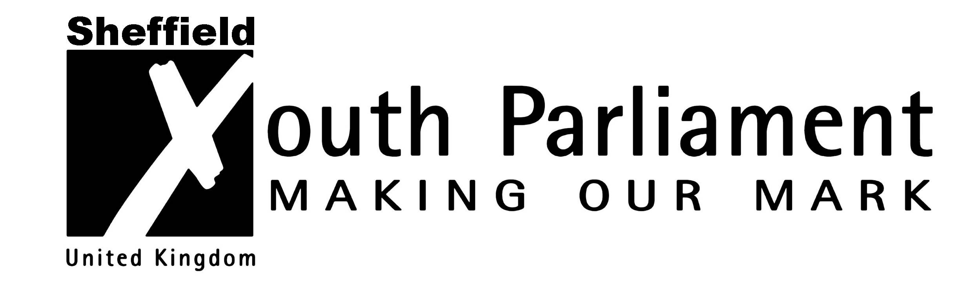

**Seats available**

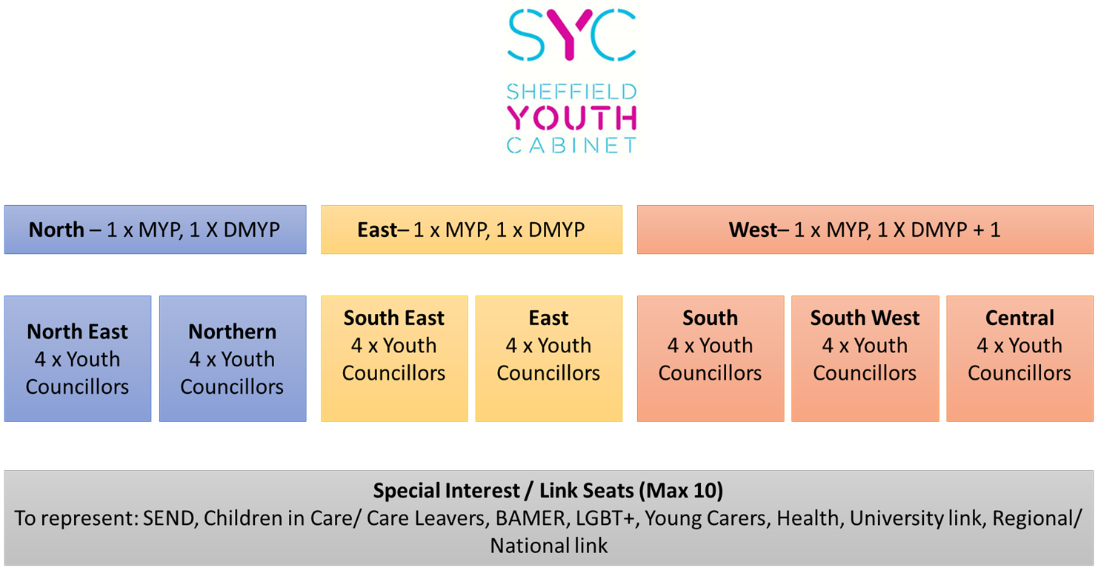

1. Any young person aged 11 to 17 (up to and including Y12’s) can stand for election.
2. Interested? Complete an Expression of interest form and return to Youth Services by **20th November.**
3. Candidates must then write a manifesto (support and guidance given)
4. Voting takes place across schools, colleges, and youth venues **29th Jan – 7th Feb 24**
5. Results will be announced at a special event on **22nd Feb 24**
6. Elected young people should be available for induction training over the following months.

We are looking for inspired and active young people aged **11 to 17**

You do not have to be academic or know everything!

It’s your passion, commitment, and enthusiasm for speaking up on behalf of others and getting your voice heard that we want!

Yes, there are skills that are useful, but we will make sure full training is given.

If this sounds like it’s for you then please contact:

**Emma Hinchliffe – Youth Voice & Influence Worker**

**E: youth.cabinet@sheffield.gov.uk**

**T: 07772887629**

for an expression of interest form or complete it online here:

<https://haveyoursay.sheffield.gov.uk/community-youth-services/survey_tools/sheffield-youth-cabinet-candidate-self-nomination-form>

Please note that this expression of interest form is not a commitment to stand as a candidate at this stage it is an opportunity to find out further information before deciding if this role would be for you.

* You can choose to stand for the area in which you live or are educated.
* You will need to stand in these elections to be a Youth Councillor in order to stand in the internal Youth Cabinet elections to be a member of UK Youth Parliament

**What do I do next?**

**What qualities do I need to have?**