**Autism Social Communication Education and Training Service**

**Graduated Response to Targeted**

**Children/Young People 5-25 Years**

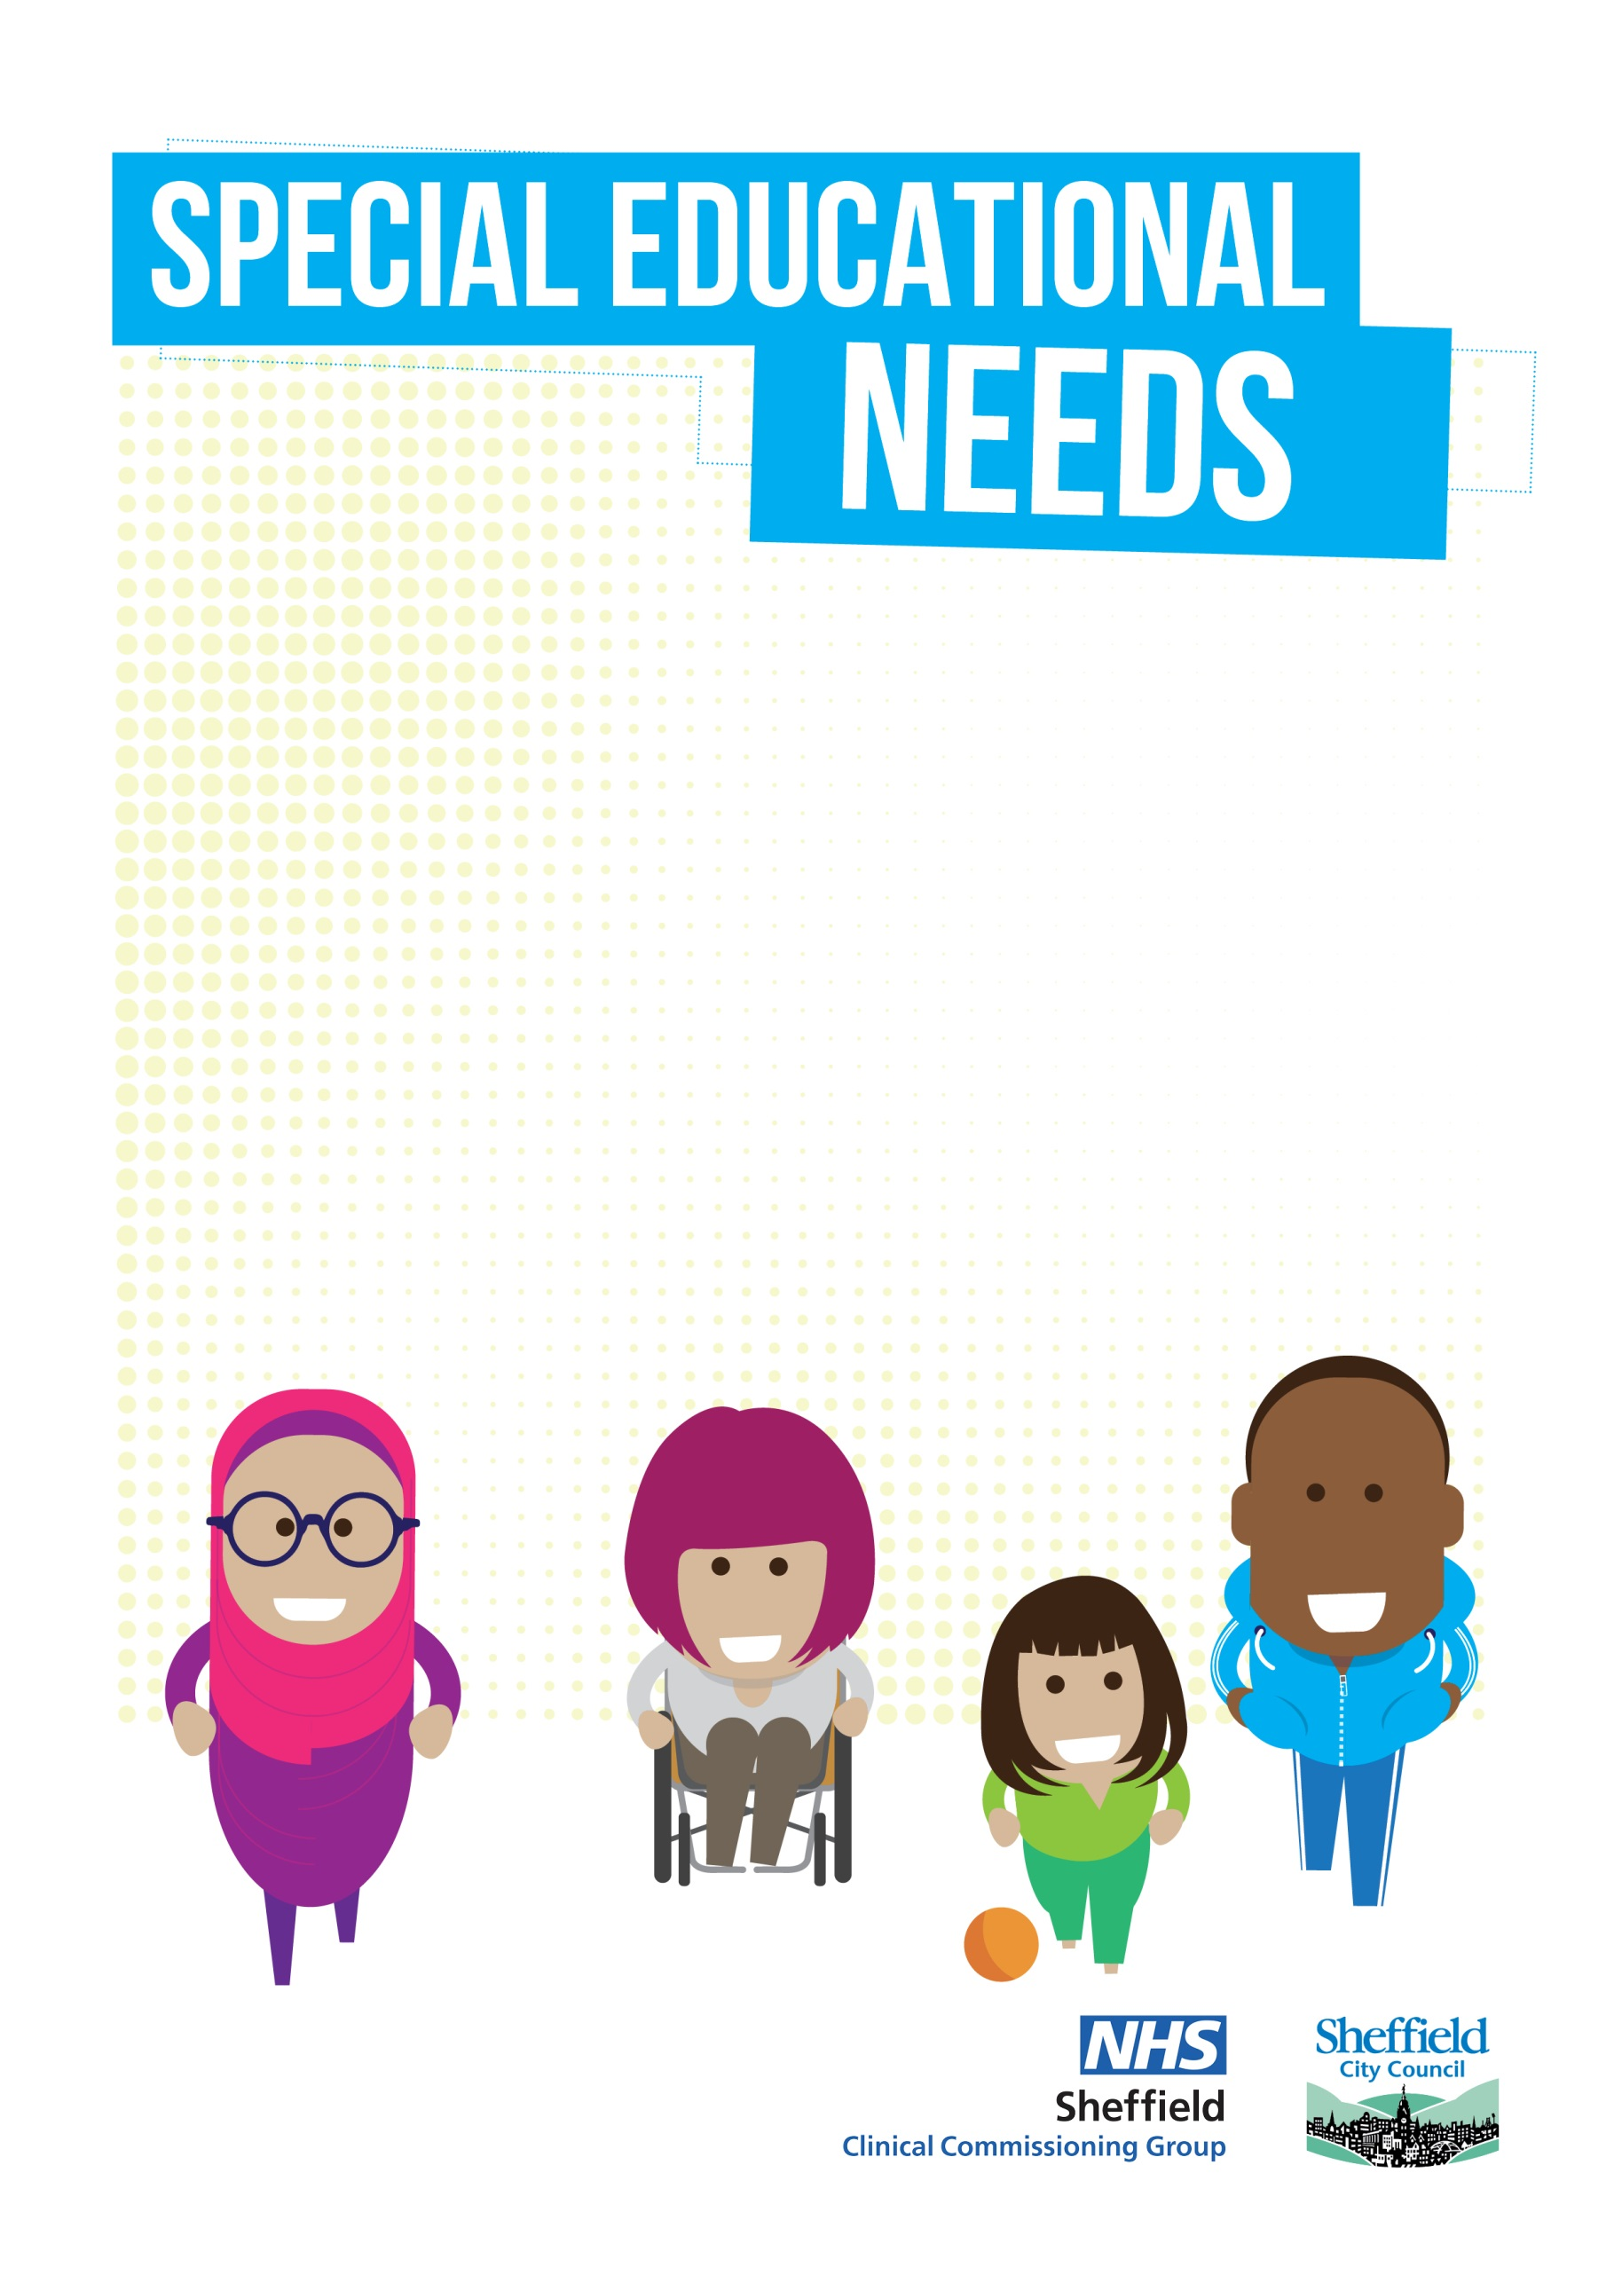

**To ensure we safeguard our capacity for the children most in need of support, we require our pupils to be displaying *significant* social communication differences (pupils may also have a diagnosis of autism but this is not required). In terms of presentation at school, has your child been levelled at 4 or higher on Early Years or Sheffield Support Grid?**

**Please contact your Link Teacher to arrange a structured conversation around a plan of support.**

**We wish the conversation to be based around what is in place and what you hope to achieve (Outcomes).**

**Following an agreement to open the pupil to targeted support, you will be asked to complete a referral which includes a Sensory Checklist and Social Communication Checklist.**

**The pupil will be opened onto our caseload, whilst the support is in place.**

**Outcomes and rating scale will be completed and revisited after support from the ASCETS to measure impact.**

**All schools are entitled to access our Universal Offer, designed to support with embedding QFT for all.**

**This offer includes school-based consultations, workshops, useful documents, and training offer.**

NO

NO

NO

YES

**Can you provide predicted outcomes (What you want to achieve) for the pupil which will be agreed and recorded on the referral to ensure our team, build upon what is currently in place.**

**Can you provide evidence of impact at SEN school support?**

Please note referrals will only be accepted from School SENCo’s with Parental Agreement

YES

YES