

Autism Social Communication Education and Training Service
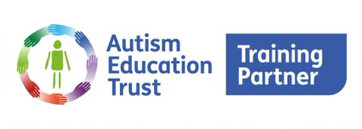
(ASCETS)

The double empathy theory challenges the idea that social difficulties are specific to autism and suggests that problems arise from a mismatch in perspective between autistic and non-autistic people.
Milton’s theory of ‘double empathy’ proposes that autistic people do not lack empathy. Instead, the difficulty in understanding and empathizing with others is mutual. Whilst it is true that autistic people can struggle to process and understand the intentions of others within social interactions, when one listens to the accounts of autistic people, one could say such problems are in both directions. The theory of the double empathy suggests that when people with very different experiences of the world interact with one another, they will struggle to empathise with each other. This is likely to be exacerbated through differences in language use and comprehension. Milton calls this disconnect a ‘double problem’, because both autistic and neurotypical people experience a lack of understanding for the other group. In other words, empathy is a ‘two-way street’.
Milton’s theory challenges the notion that Autistic people lack ‘theory of mind’. It reframes the division between Autistic and non-autistic communities. It highlights the importance of understanding and empathy in building relationships within an inclusive environment.
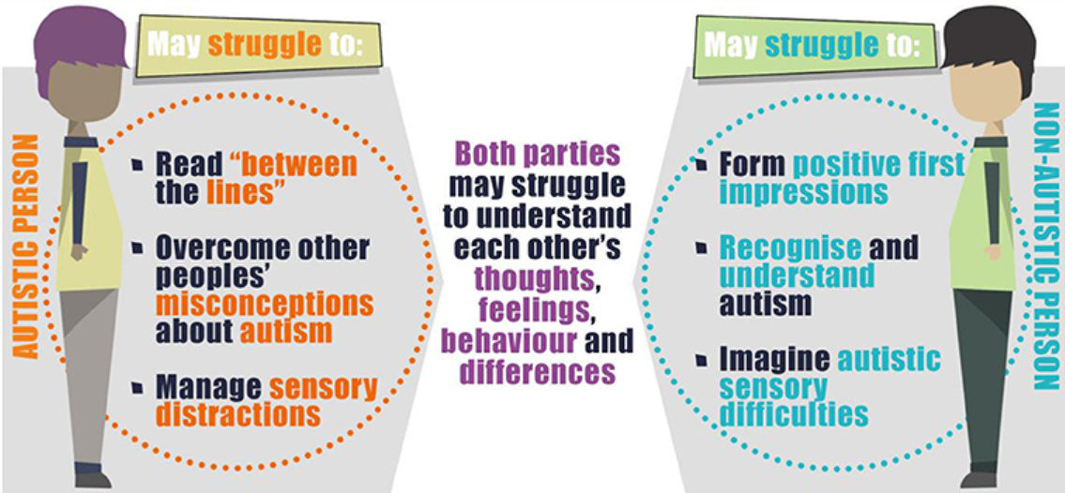
Further reading:
Dr Damian Milton (2017), A mismatch of salience. Pavilion
Milton, D. (2012) On the Ontological Status of Autism: the ‘Double Empathy Problem’. Disability and Society. Vol. 27(6): 883-887.

