

**Are you a Young Resident with SEND? (Special Educational Need or Disability)**

**Are you 13 to 24 years old?**

**Then join our   
SENDing voices group!**

**Want to help make things better for you and others?**

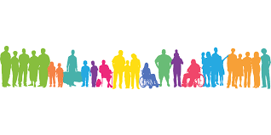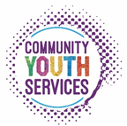

[**youth.voice@sheffield.gov.uk**](mailto:youth.voice@sheffield.gov.uk)

**07391 739 118 (Kerry)**



[**youth.voice@sheffield.gov.uk**](mailto:youth.voice@sheffield.gov.uk)

**07391 739 118 (Kerry)**



**What do I get out of being involved?**

* A chance to talk about and share your experiences.
* Share ideas with decision makers.
* Help to make SEND services better for young residents in Sheffield.
* Meet new people and make new friends.
* Learn new skills.
* Develop your CV and build relationships.
* Join in with fun activities.

**What will I do?**

* Attend a meeting once a month – meetings will be in an accessible venue in Sheffield City Centre or online.
* Talk about you and your friends’ experiences of being a young resident with SEND.
* Work on important issues
* Work together with other young people and adults to help make things better.

