The interoceptive system relates to our ability to feel what is happening inside our body. Interoception means sensing internal signals from our body, like when we are hungry, when our heart is beating fast, or when we need the toilet.

Parts of our brain are constantly tracking our internal signals to keep our body functioning properly and to notify us when something changes. For example, our brains might notice we are running low on water, prompting us to feel thirsty and grab a drink.

Interoception helps us to learn about our emotions through the physical sensations in our bodies. For example feeling ‘butterflies’ in our tummy when we are nervous. This occurs due to the body noticing internals signals/sensations and connecting these sensations to emotions. Interoception impacts our ability to self-regulate, which is our “…ability to identify and manage…” how we feel.

Sometimes the signals/sensations are too strong or there are too many, other times they are too weak or they are unclear regarding the origin or type of sensation. This can impact a pupils’ ability to experience and express emotions and their ability to self-regulate, as they might not be receiving sufficient information or the correct information internally to help them identify their emotions. This then results in them being unable to manage and regulate their emotions. Inability to regulate or dysregulation is most often seen in the pupil’s behaviour.

ve system relates to our ability to feel what is happening inside our

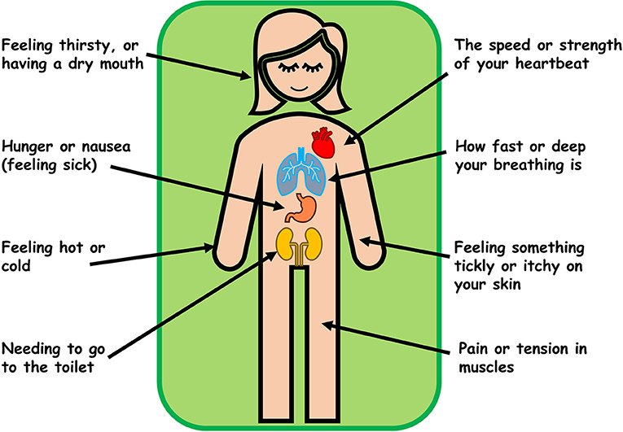

body. It provides information about internal regulation, for example when we feel thirsty, hungry and full, regulating body temperature, heart and breathing rates, social touch, muscle tension, itching, feeling nauseas and regulating sleep.

**Interoception**