

**Mini Pizza**

*Have a go at these easy to make mini-Pizzas. A great way to add veg to your child’s diet.*

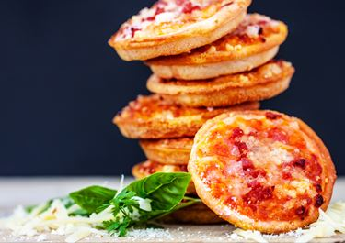

**Ingredients**

**(Prep time 5 mins, cooking time 5 mins)**

* 4 English muffins

**To serve….**

* A few lettuce leaves
* Sliced cucumber
* Potato salad or coleslaw
* Grated carrot
* 1 fresh pepper
* 6 cherry tomatoes
* 4 button mushrooms
* 4 slices of Turkey or Ham
* 6 – 8 tablespoons of grated cheese
* 8 tablespoons of passata or tinned tomatoes
* 1 teaspoon of dried herbs.

**Method **

1. Grate the cheese, **chop** the ham, **wash**, **peel** and fine chop the veg
2. **Mix** the dried herbs into the tomato sauce
3. Halve the muffins and grill one side until golden brown
4. On the side of the muffin not grilled, spread tomato sauce, then sprinkle the grated cheese on and add the chopped veg and ham
5. Place back under the grill until the cheese is bubbling (about 3-5 mins)
6. Remove from the grill – All Done!

Make sure the cheese has cooled a bit before giving to children

**mash   mix shape cut**

**Symbols** and **words** show food skills that children (dependent on age and adult support) can do.