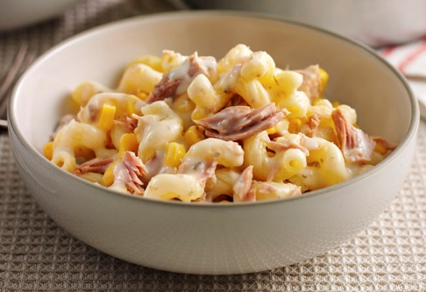

***Tuna and Sweetcorn Pasta***

**Ingredients**

**(Prep time 10 mins cooking time 20 minutes)**

* 250gms of pasta

**To serve….**

* Remember me size portions
* Right size plates/bowls
* Serve with a mixed salad or garlic bread
* 400gms chopped tomatoes/passata
* 1 clove garlic
* 1to 2 teaspoon of dried herbs
* 1 tablespoon of tomato puree
* 1 to 2 tins of Tuna
* 1 small tin of Sweetcorn
* 60gms of grated cheese

**Method  **

1. Cook the pasta in a large pan of boiling water – follow the instructions on the packet
2. Heat the chopped tomatoes and the tomato puree in another pan then add the garlic and herbs and then leave to simmer for 5- 6 minutes
3. Turn off the sauce then add the tuna and sweetcorn and stir in well.
4. Drain the pasta then add to the pan of sauce and mix well
5. Dish out and sprinkle on grated cheese

**mash   mix shape cut**