

**Flapjack**

*Have a go at this easy to make flapjack this recipe is from The Sheffield Guide to Smart Sugar Swaps (Sheffield is Sweet Enough 2020),*

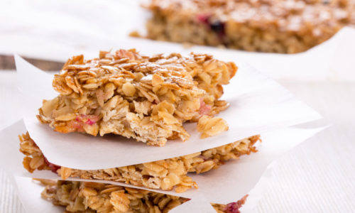**Ingredients**

* 150g (2 cups) rolled oats
* 1 tbsp desiccated coconut
* 50g (⅓ cup) coconut oil or butter
* 1½ bananas
* 3 dates
* 4 tbsp orange juice or apple juice

**Method**

1. Preheat oven to 170°C / 340°F / Gas mark 3 and line a baking dish with some parchment.
2. Blitz the oats in a food processor for a few seconds to break them down a bit. Transfer the oats into a large bowl and **mix** in the desiccated coconut.
3. Melt the coconut oil or butter in a pan or use a microwave.
4. In a blender blitz the melted coconut oil or butter, bananas, dates and fruit juice until it forms a sticky paste. Pour this on top of the oat mixture and stir until everything is well combined.
5. **Scoop** the mixture into the dish and press down with the back of the spoon to make it compact.
6. Bake in the oven for 20 – 25 minutes or until the edges of the mixture are beginning to brown.
7. Lift the parchment paper out of the dish and leave to cool before cutting into 8 large or 16 small pieces.

**mash   mix shape cut**

**Symbols** and **words** show food skills that children (dependent on age and adult support) can do.