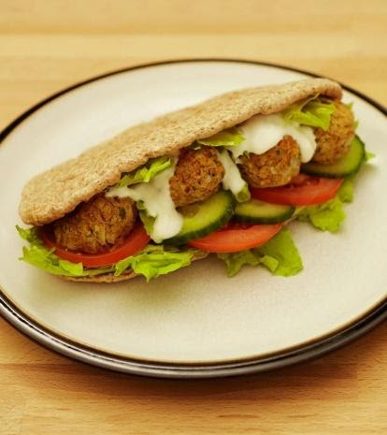****

**Fantastic Falafels**

*Have a go at this easy to make baked version of this Middle Eastern dish. Great served in warmed pitta breads served with salad for lunch or served warm with couscous and vegetables for dinner.*

**Ingredients (Makes 4 fabulous portions)**

* 400g tinned chickpeas in water, rinsed and drained

**To serve….**

* 4 wholemeal pitta breads
* A few lettuce leaves
* 2 medium tomatoes sliced
* ¼ cucumber sliced
* 4 tbsp Greek yoghurt (reduced or zero fat for over 5’s)
* 1 small onion, peeled
* 1 clove garlic, peeled
* Wholemeal breadcrumbs (from 1 slice of bread)
* 1 tsp ground cumin
* 1 tsp ground coriander
* 2 tbsp chopped fresh parsley
* 1 tbsp olive oil

**Method**

Chop the [onion](https://www.nhs.uk/change4life/recipes/falafels-recipe) and [garlic](https://www.nhs.uk/change4life/recipes/falafels-recipe) finely (You can use food processor or hand blender for this)

**Mash** the chickpeas with a fork or potato masher.

Add the [chickpeas](https://www.nhs.uk/change4life/recipes/falafels-recipe), [breadcrumbs](https://www.nhs.uk/change4life/recipes/falafels-recipe), [cumin](https://www.nhs.uk/change4life/recipes/falafels-recipe), [coriander](https://www.nhs.uk/change4life/recipes/falafels-recipe), [parsley](https://www.nhs.uk/change4life/recipes/falafels-recipe) and [olive oil](https://www.nhs.uk/change4life/recipes/falafels-recipe), and **mix** together

**Shape** into 16 balls and place on a greased or lined baking tray. Chill for 30 minutes.

Place tray into a preheated oven (200°C/180°C fan/gas mark 6) and bake for about 25 minutes, turning the falafel to prevent sticking.

**Cut** the tomato and cucumber into slices

To **assemble**, fill each [pitta](https://www.nhs.uk/change4life/recipes/falafels-recipe) with [lettuce](https://www.nhs.uk/change4life/recipes/falafels-recipe), sliced [tomatoes](https://www.nhs.uk/change4life/recipes/falafels-recipe) and [cucumber](https://www.nhs.uk/change4life/recipes/falafels-recipe), falafel and some yoghurt.

**mash   mix shape cut**

**Symbols** and **words** show food skills that children (dependent on age and adult support) can do.

Let’s get Cooking!

Figure 1Lets get Active!