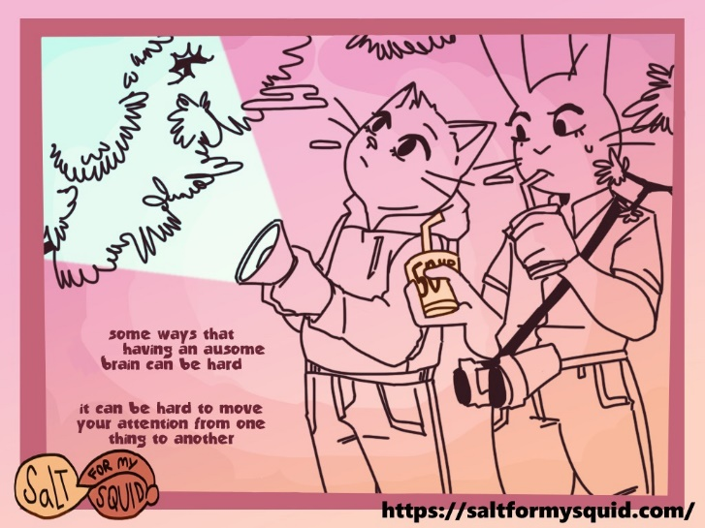

Monotropism is a processing style, or way of thinking. Monotropic people tend to focus strongly on a small number of things at a time and miss things outside of their attention tunnel — or quickly forget things they are no longer focusing on. Autistic and ADHD people and are more likely to be monotropic than others. They might experience some things intensely, and often find it hard to shift their attention from one thing to another. This can result in [passionate interests](https://autismunderstood.co.uk/autistic-differences/special-interests/) that some people might find unusual.

Most people are more *polytropic*, which is the opposite of being monotropic: they can spread their attention between several things. When they are communicating, these people often find it easy to follow someone’s words *and* facial expressions *and*body language*and*tone of voice, all at the same time — all while expressing themselves through all of those channels as well! Not only that, but they do this while keeping in mind who it is they’re talking to, what *they’re* interested in, how long they’ve been talking, and the relationship between them. For example, if the other person is in a position of power, like a teacher or police officer, they might expect to be spoken to a certain way.

Because monotropic and polytropic people tend to communicate very differently from one another, misunderstandings often arise (see: [*double empathy*](https://autismunderstood.co.uk/social-stuff/double-empathy/)). Polytropic people might think that monotropic people are being distant or disrespectful, when really, they are just struggling to manage all of the things that polytropic people consider ‘polite’, because there are too many things to keep track of at once!

The idea of monotropism is something that autistic people came up with, to try and explain all the different things about being autistic.

***Credit:*** [***https://autismunderstood.co.uk/autistic-differences/monotropism/***](https://autismunderstood.co.uk/autistic-differences/monotropism/)

**Monotropism**