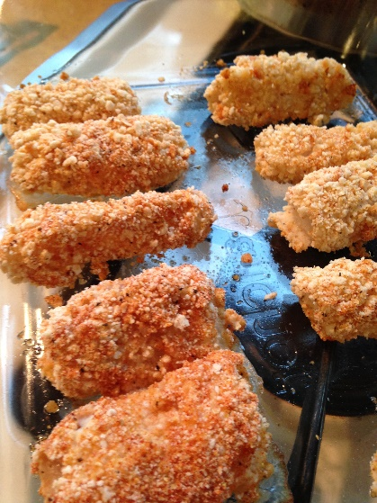

**Garlic bread Fish Fingers**

*A great source of protein*

**Ready in 30 mins**

**Ingredients to make 6 fish fingers**

* 2 fillets of white fish
* 1-2 tablespoons of yoghurt (could be diary free) or garlic & herb cream cheese loosened with a little milk.
* 70 -100g of breadcrumbs (about 2 slices of bread)
* 1 heaped teaspoon of parsley or oregano
* 1 – 2 teaspoons of garlic granules

**Method**

1. **Cut** the fish into slices to make goujons or finger shapes
2. On a plate **mix** your breadcrumbs and herds
3. Coat the fish in yoghurt or cream cheese then drop into the breadcrumbs and **roll** until the fish is covered evenly.
4. Do this for all the fish fingers
5. Place on a baking tray and cook in the oven for 15 – 20 minutes (until the outside looks golden and the fish is cooked all the way through)

** cut Roll mix**

Recipe shared from Children’s Dietitian Instagram

The **Symbols** and **words** show food skills that children (dependent on age and adult support) can do.