**Training and Coaching is available from ASCETS!**

**Please contact your link teacher for further information!**

**The Low Arousal Approach**

**Within the ASCETS, we have Studio 3 ‘Train the Trainers’** [**www.studio3.org.uk**](http://www.studio3.org.uk)**. Studio 3 are innovators of The Low Arousal Approach. This means it emphasises a range of strategies that focus on the reduction of stress, fear and frustration for pupils. These strategies are put in place to prevent dysregulation and avoid crisis situations. The low arousal approach seeks to understand the role of the ‘situation’ by identifying triggers and using low intensity solutions to avoid reactive consequences for individuals with additional needs.**

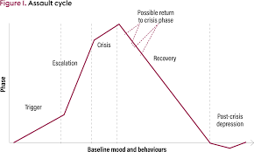

**In applying the Low Arousal approach to teaching and learning it is all about the culture within the classroom; founded on a good understanding of stress and consistent proactive approaches. Maintaining a calm, consistent learning environment, applying what the evidence would suggest is a good investment in learning, creates a purposeful environment that allows everyone the opportunity to thrive.**

*Creating a calm, consistent, positive learning environment benefits everyone!*

