

**Halloween Stuffed Peppers**

*Celebrate Halloween with these spooktacular Stuffed peppers, they are perfect for a Halloween buffet or a family meal before you head out trick or treating. (recipe taken from BBC good food)*

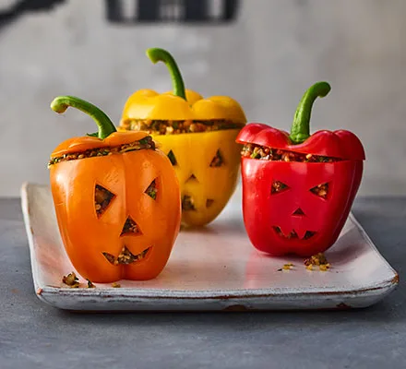

**Ingredients**

* 4 small peppers (a mix of orange, red and yellow looks nice)
* 25g pine nuts
* 1 tbsp olive or rapeseed oil
* 1 red onion, chopped
* 2 fat garlic cloves, crushed
* 1 small aubergine, chopped into small pieces
* 200g pouch mixed grains (we used bulghur wheat and quinoa)
* 2 tbsp sundried tomato paste
* zest of 1 lemon
* bunch basil, chopped

**Method**

1. Cut the tops off the peppers leaving them to one side. Remove any seeds and white flesh. Using a sharp knife carve spooky faces onto one side of the pepper. Cut up the onion and garlic.
2. Toast the pine nuts in a pan until golden brown and leave to one side. Heat the oil in the pan and preheat the oven to 200c/180c fan/ gas mark 6. Cook the onion for 8-10 minutes until softened. Add the garlic and aubergine add a splash or water if the pan looks dry. Lift the parchment paper out of the dish and leave to cool before cutting into 8 large or 16 small pieces.
3. Add the pouch of grains to the pan with the tomato past and stir for a few minutes. Then remove form the heat and add the basil, lemon zest and pine nuts
4. Fill each pepper with the grain mixture. Replace the lids, using cocktail sticks to secure them in place, and put the peppers in a deep roasting tin with the carved faces facing upwards. Cover with foil and bake for 35 mins, uncovered for the final 10. The peppers should be soft and the filling piping hot.