**Healthy Pancakes**

*Sweet and fruity*



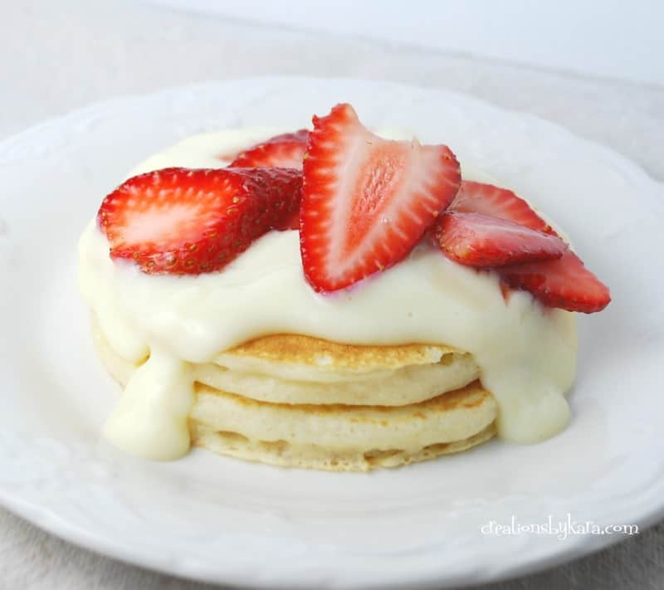**Prep time 5 mins cooking time 2 minutes**

**Ingredients**

* 50g self-raising flour
* 50g wholemeal or wholegrain flour
* 2 small eggs
* 150mls skimmed milk
* Berries, yoghurt or fromage frais

**Method **

1. Mix the flour and egg yolks in a big bowl with a splash of the milk (to make a paste)
2. Then add the rest of the milk a little at a time, so you do not get lumps
3. Whisk the egg whites until they stand in peaks, then fold carefully into the batter. Try not to squash all the air out
4. Heat a non-stick pan over a medium heat
5. Pour enough pancake batter into the pan to make a pancake 10cm across
6. Cook for just under 1 minute- until bubbles start popping to the surface
7. Then carefully turn over (flip) and cook for another minute
8. Pancake is now ready to serve

**mash   mix shape cut**

**Symbols** and **words** show food skills that children (dependent on age and adult support) can do.

Recipe from BBC food guide