**Autism Social Communication Team**

**Graduated Response**

**5 – 25 Years**

[Universal](https://www.sheffielddirectory.org.uk/localoffer/about-the-local-offer-and-other-information/how-to-access-council-education-and-social-care-services/autism-and-social-communication-team/) Targeted – See below

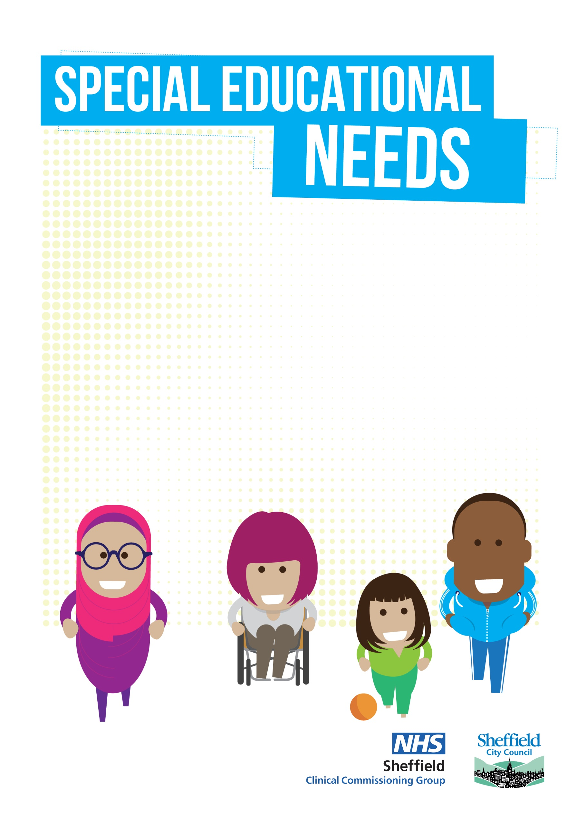

**To ensure we safeguard our capacity for the children most in need of support, we require our pupils to have a diagnosis of autism OR be displaying *significant* social communication differences. In addition, and in terms of presentation at school, they would have been levelled at 4 (refer to Universal Offer) or higher on Early Years or Sheffield Support Grid and we would prioritise those for whom a mainstream school place, is at risk.**

NO

NO

NO

**All schools are entitled to access our Universal Offer, designed to support with embedding QFT for all.**

**This offer includes consultations, workshops, useful documents, and training videos.**

YES

**Can you provide predicted outcomes (What you want to achieve) for the pupil which will be agreed and recorded on the referral to ensure our team, build upon what is currently in place in line with the Graduated Response.**

**Can you provide evidence of recent reviewed SEN school support?**

Please note referrals will only be accepted from School SENCo’s with Parental Agreement

**Please contact your Link Teacher to arrange a structured conversation around a plan of support.**

**We wish the conversation to be based around what you hope to achieve (Outcomes)**

**Following the conversation, you will be asked to complete a referral which includes a Sensory Checklist and Social Communication Checklist.**

**The pupil will be opened onto our caseload, whilst the support is in place.**

**Outcomes and rating scale will be completed and revisited after support from the ASC Team to measure impact.**

YES

YES